1. The first thing you need to do is set a static IP for the server. Start by opening the Control Panel.  
   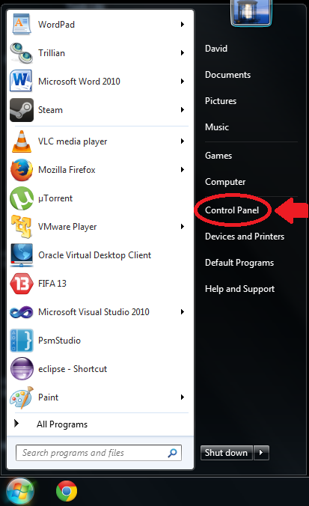
2. Under “Network and Internet”, click “View network status and tasks.” This will open the Network and Sharing Center.  
   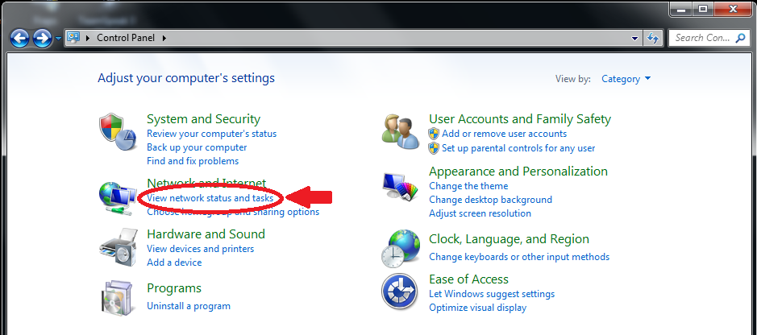
3. Then click ‘Change adapter settings”  
   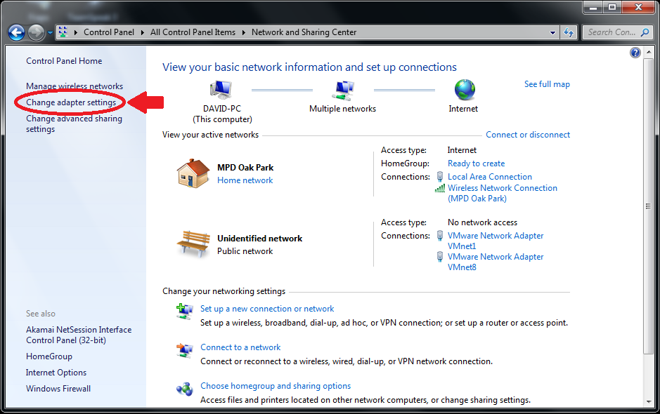
4. Find the wireless network card you’re going to use, right click it and select “Properties”  
   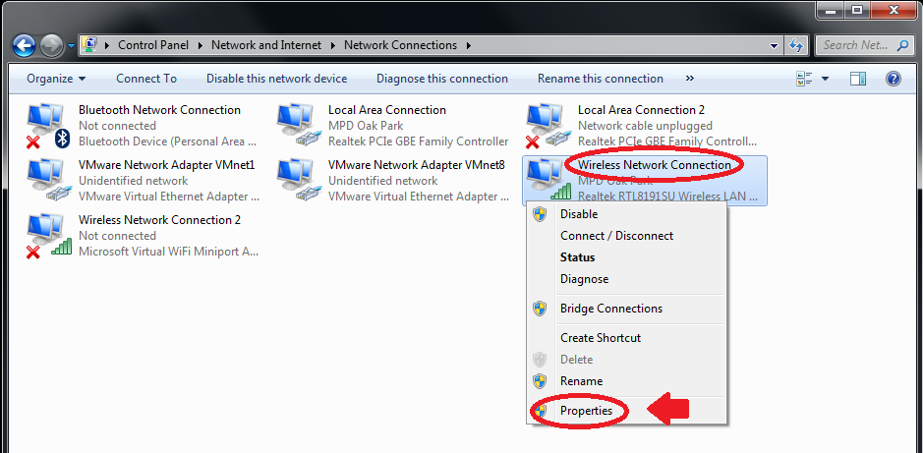
5. Select “Internet Protocol Version 4 (TCP/IPv4) and the click “Properties”  
   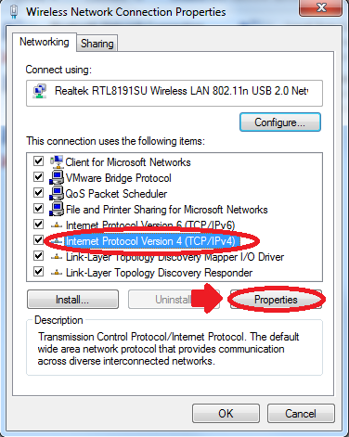
6. Under the “General” tab adjust the settings to match the picture. Then click OK.  
   Select ‘Use the following IP address’   
   IP address: 192.168.0.1  
   Subnet mask: 255.255.255.0  
   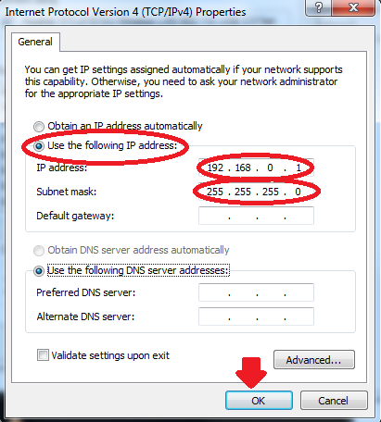
   1. The computer will now have a static IP and it’s time to set up the Ad Hoc server.
7. To set up the Ad Hoc server first go to the “Network and Sharing Center.” Do this by following steps 1 and 2. From here click “Manage wireless networks”  
   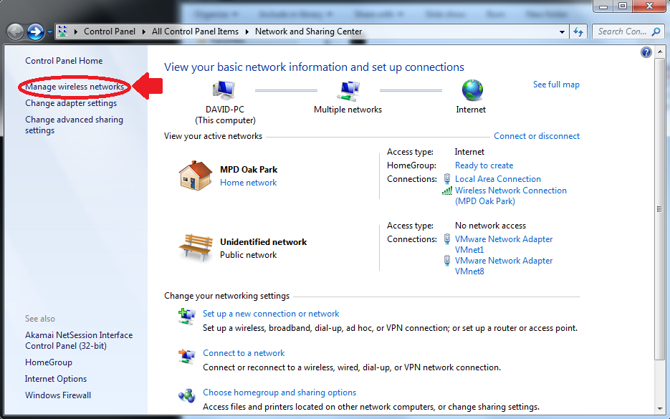
8. Click “Add”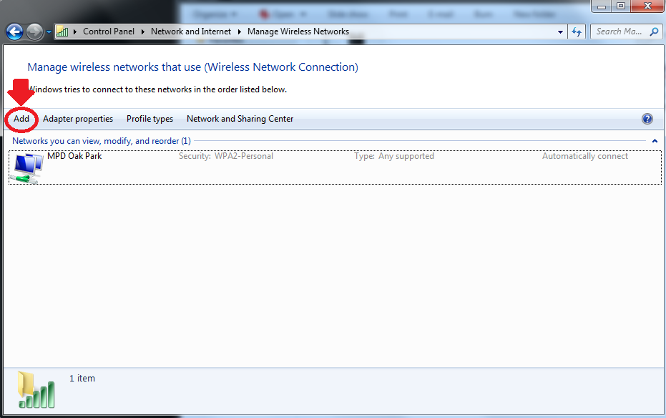
9. Select “Create an ad hoc network”  
   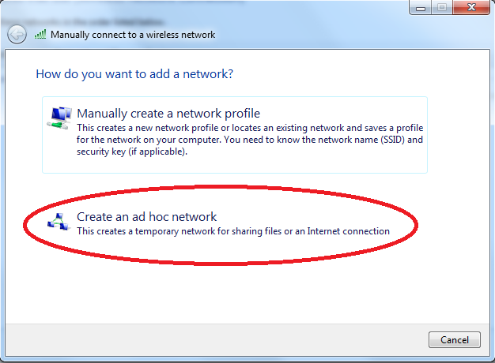
10. Name the network fEMR-AdHoc, use WPA security, and set the password to 12345678. (You can name the network whatever you want, use any type of security, and use any or no password. The ones provided are merely a suggestion.)  
    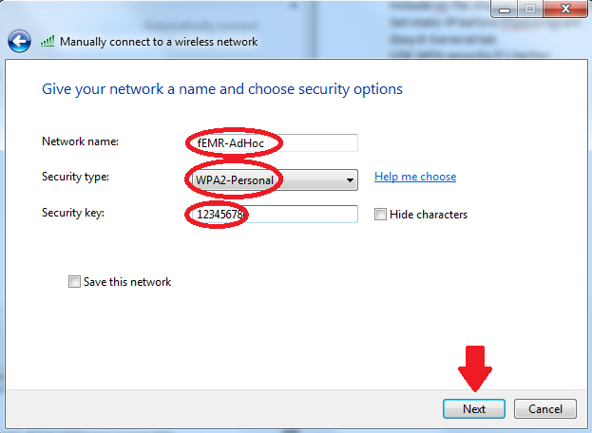
    1. The Ad Hoc server is now set up. You now have to set up the DHCP server before anyone connects.
11. Download ([link here](http://tftpd32.jounin.net/)) Tftpd32 standard edition or Tftpd64 standard edition, if you have a 32 bit OS download Tftpd32, if you have a 64 bit OS download Tftpd64. If you don’t know what type of OS you have get the 32 bit one. Run the Tftpd program as administrator, do this by right clicking the tfptd icon.  
    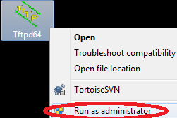
12. Press settings in the program  
    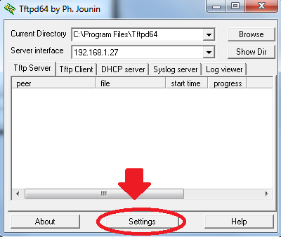
13. Under the General tab make sure the only boxes checked are DHCP server and Enable IPv6.  
    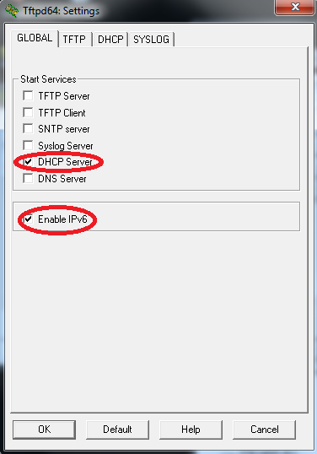
14. Select the DHCP tab and adjust the settings to the ones show in the picture and below. Then click OK.   
    IP pool starting address: 192.168.0.10  
    Size of Pool: 50  
    Mask: 255.255.255.0  
    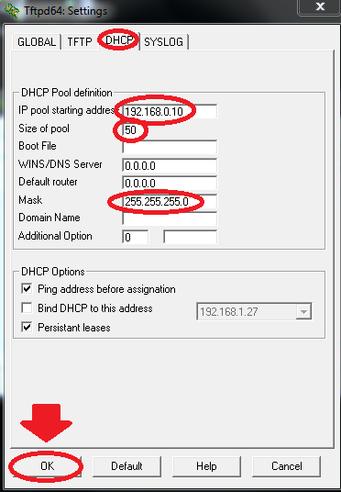
    1. The DHCP server is now set up; make sure you leave the Tftpd program on.
15. The ad Hoc network is now set up with a static IP and DHCP server, have someone connect to the server and wait for them to be assigned an IP. Clients can access the server by typing 192.168.0.1:9000 (if that doesn’t work just type 192.168.0.1) in to their URL.

BUGS AND STUFF

It can take a long time for a client to be assigned an IP, once the IP is assigned it’s permanent unless the admin deletes in in tftpd program

Make sure you run the tftpd program w/ administrator privileges

If there are multiple network connections (LAN and WLAN) make sure the IP is set in the general tab. You can also just disable all active connections beside WLAN.

You can check your IP by typing

Ipconfig

In the command prompt

If the IP is wrong do…

Ipconfig /release

Ipconfig /renew

…in the command prompt

If there is only the one Wireless connection you can change the tftpd3.ini file so that at the bottom of the DHCP part you put the MAC address = IP address you want.

You can find your MAC address by typing ipconfig /all in the command prompt

Ex. 0A:0B:0C:0D:0E=192.168.0.1